Resource Curse and Economic Complexity
Capstone Project — Chart Overview

54 Resource-Rich Countries · 1995–2019 · NB0 → NB6 Pipeline

0 Model Performance Overview
The chart below summarises predictive performance across all models estimated in the project. The left panel shows ML models (LASSO, Ridge, Elastic Net, Random Forest) on the ECI-level target, comparing training R² (1995–2014) against out-of-sample test R² (2015–2019). All models generalise well, with test R² between 0.85 and 0.87, and negative overfit gaps indicating the models perform slightly better on the hold-out set — consistent with the strong autocorrelation in ECI levels. Random Forest achieves the highest test R² (0.869). The right panel shows R² for all nine OLS specifications (NB6). Models incorporating a lagged ECI term (M2, M3b–M4b) cluster around R² ≈ 0.77–0.80, while the contemporaneous interaction model without a lag (M3a) is markedly lower (0.376), confirming that ECI persistence dominates year-on-year variation. The first-difference model (M6, ΔECl) achieves only R² = 0.119, consistent with the low short-run signal once level persistence is removed.
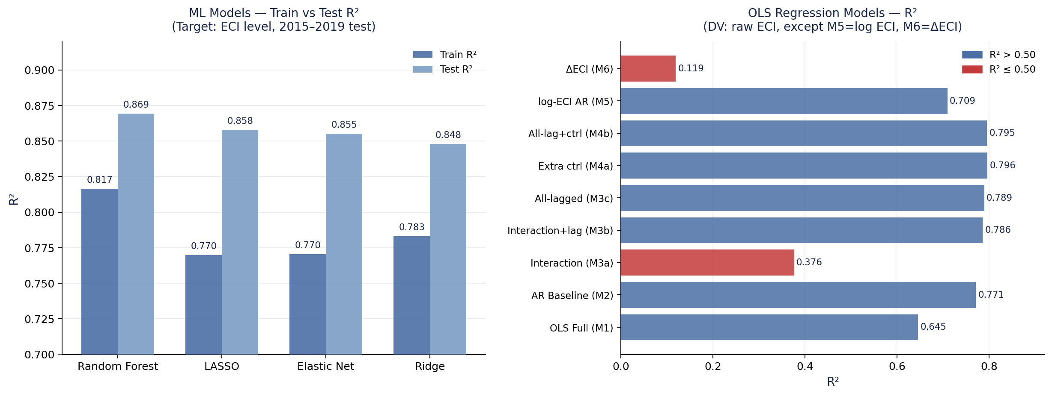
Figure 0. Left: ML model train vs test R² (ECI level target, 2015–2019 hold-out). Right: OLS model R² across all nine specifications in NB6.

1 Descriptive Analysis

1.1 Variable Correlations with ECI
Figure 1 reports Pearson correlations between each covariate and the Economic Complexity Index across the full 54-country panel (1995–2019). Variables are grouped into five thematic categories. Human capital and infrastructure variables (Human Capital, Life Expectancy, Electricity Access) show the strongest positive associations with ECI (r ≈ 0.50–0.52), closely followed by financial depth (Domestic Credit, r ≈ 0.60) and GDP per capita (r ≈ 0.51). Resource rent variables — Natural Gas Rents, Oil Rents, Mineral Rents, and Total NR Rents — are uniformly negative or near-zero, providing preliminary bivariate support for the resource curse hypothesis. Governance indicators (Political Stability, Rule of Law) show moderate positive correlations (~0.30–0.35), while macro variables are mixed, with Lending Rate and Political Corruption both strongly negative.
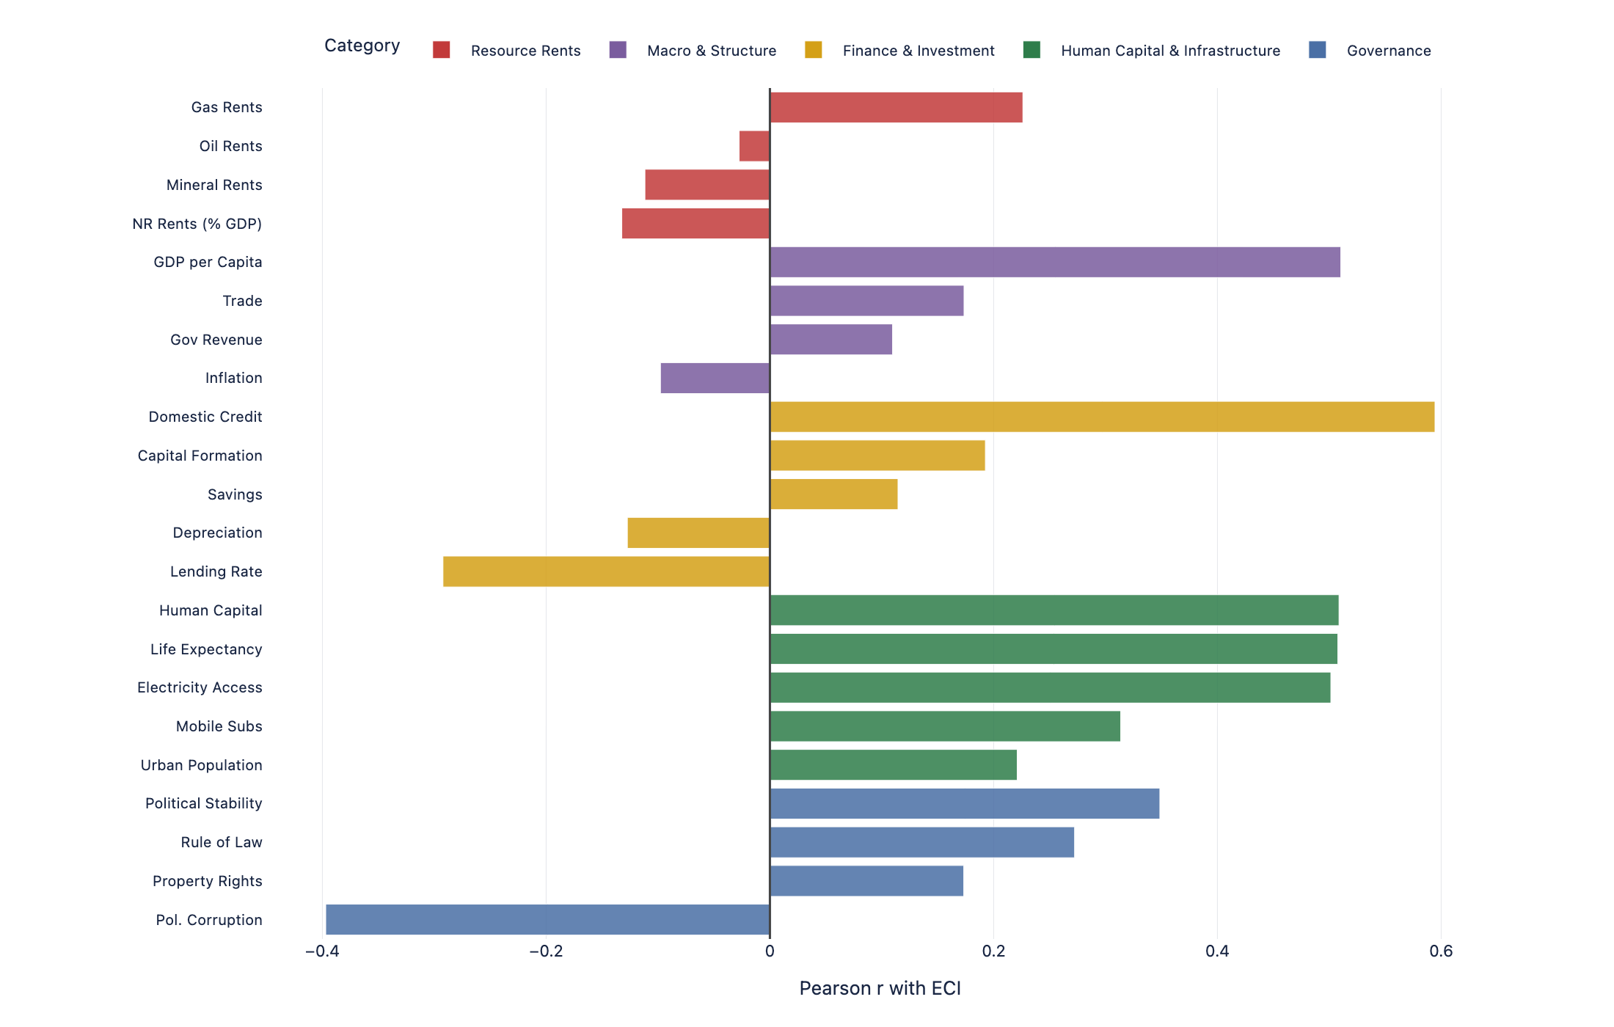
Figure 1. Pearson correlations between panel covariates and the Economic Complexity Index (ECI), 54-country sample, 1995–2019. Colour denotes variable category.

1.2 ECI Distribution Shift: 1995 vs 2019
Figure 2 overlays the empirical CDF of ECI in 1995 (blue) and 2019 (red) for the 54-country sample. The distribution has shifted rightward at the top end — the 90th percentile rises from roughly −0.1 in 1995 to +0.5 in 2019 — while the bottom decile has actually worsened slightly (from −2.5 to −1.8). This divergence pattern is consistent with a small number of countries making substantial diversification gains while the majority remain trapped at low complexity levels, suggesting that the resource curse effect operates heterogeneously across the sample.
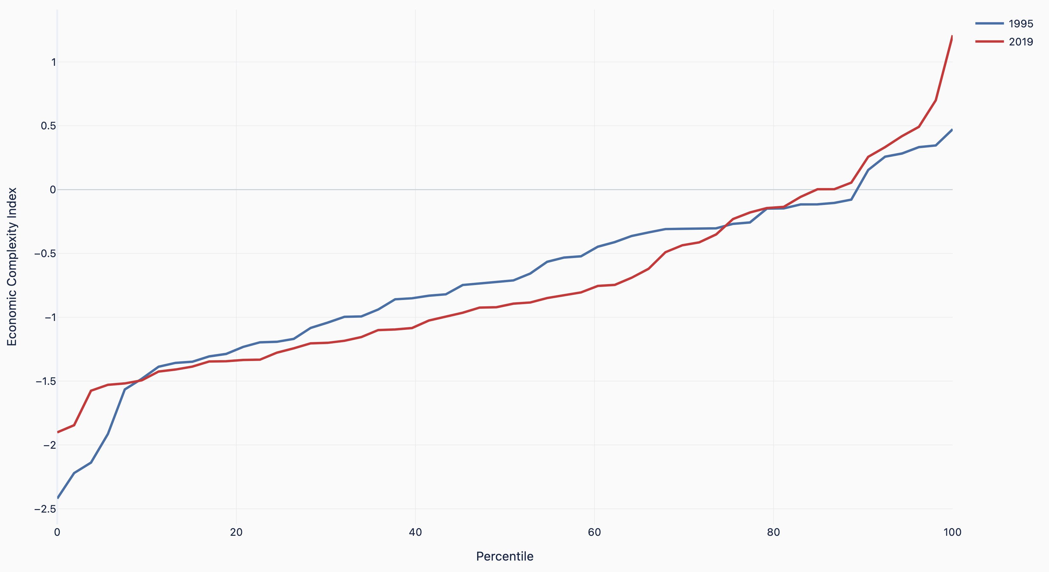
Figure 2. Empirical CDF of ECI in 1995 (blue) and 2019 (red), 54-country sample. The x-axis is the sample percentile rank.

1.3 Median ECI Trajectory by Cluster
Figure 3 plots median ECI over time for each of the five resource-profile clusters (k=5, 1995 assignment). Petrostates (orange) start at the highest median ECI in the sample and exhibit the most volatility, with a sharp spike around 2004–2006 driven by the oil price boom, followed by a reversion. Diversified Producers (green) and Mining Exporters (purple) occupy intermediate positions with gradual improvement over the period. Oil Exporters (blue) remain persistently at the bottom, with median ECI well below −1.0 throughout, consistent with extreme export concentration in crude oil. Forestry Intensive countries (red) are stable and low, around −1.0, with no convergence trend visible over the 25-year window.
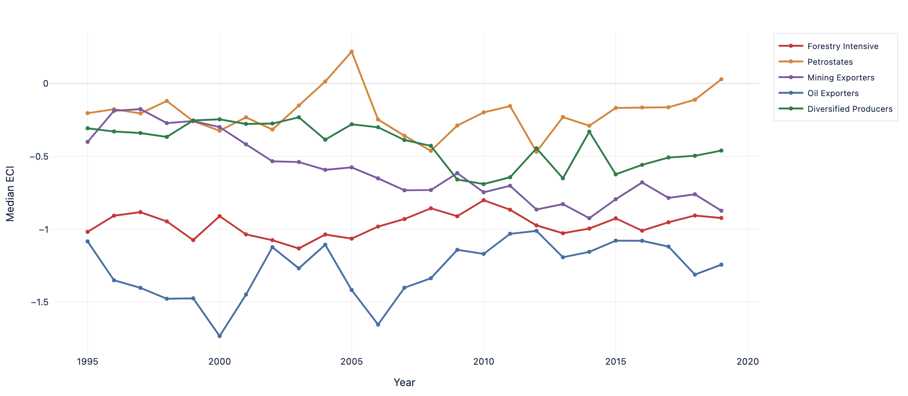
Figure 3. Median Economic Complexity Index by resource-profile cluster, 1995–2019. Clusters assigned using 1995 PCA+KMeans (k=5).

2 Resource Profile Clustering

2.1 PCA Biplot — 1995 Cluster Assignments
Figure 4 shows the PCA biplot for 1995, with countries plotted in the space of the first two principal components (PC1: 51.8% variance, PC2: 17.7% variance) and coloured by their k=5 cluster assignment. Loading arrows indicate the contribution of key resources to each axis. PC1 is dominated by Oil and Natural Gas (pointing strongly rightward), separating Gulf petrostates and oil exporters from all other countries. PC2 separates Copper, Gold, and Coal producers (upward) from the rest. Chile (CHL) and Mongolia (MNG) stand apart from other Mining Exporters due to particularly high copper and coal loadings. Russia (RUS) and Kazakhstan (KAZ) sit in the Diversified Producers cluster, reflecting significant production across multiple resource categories.
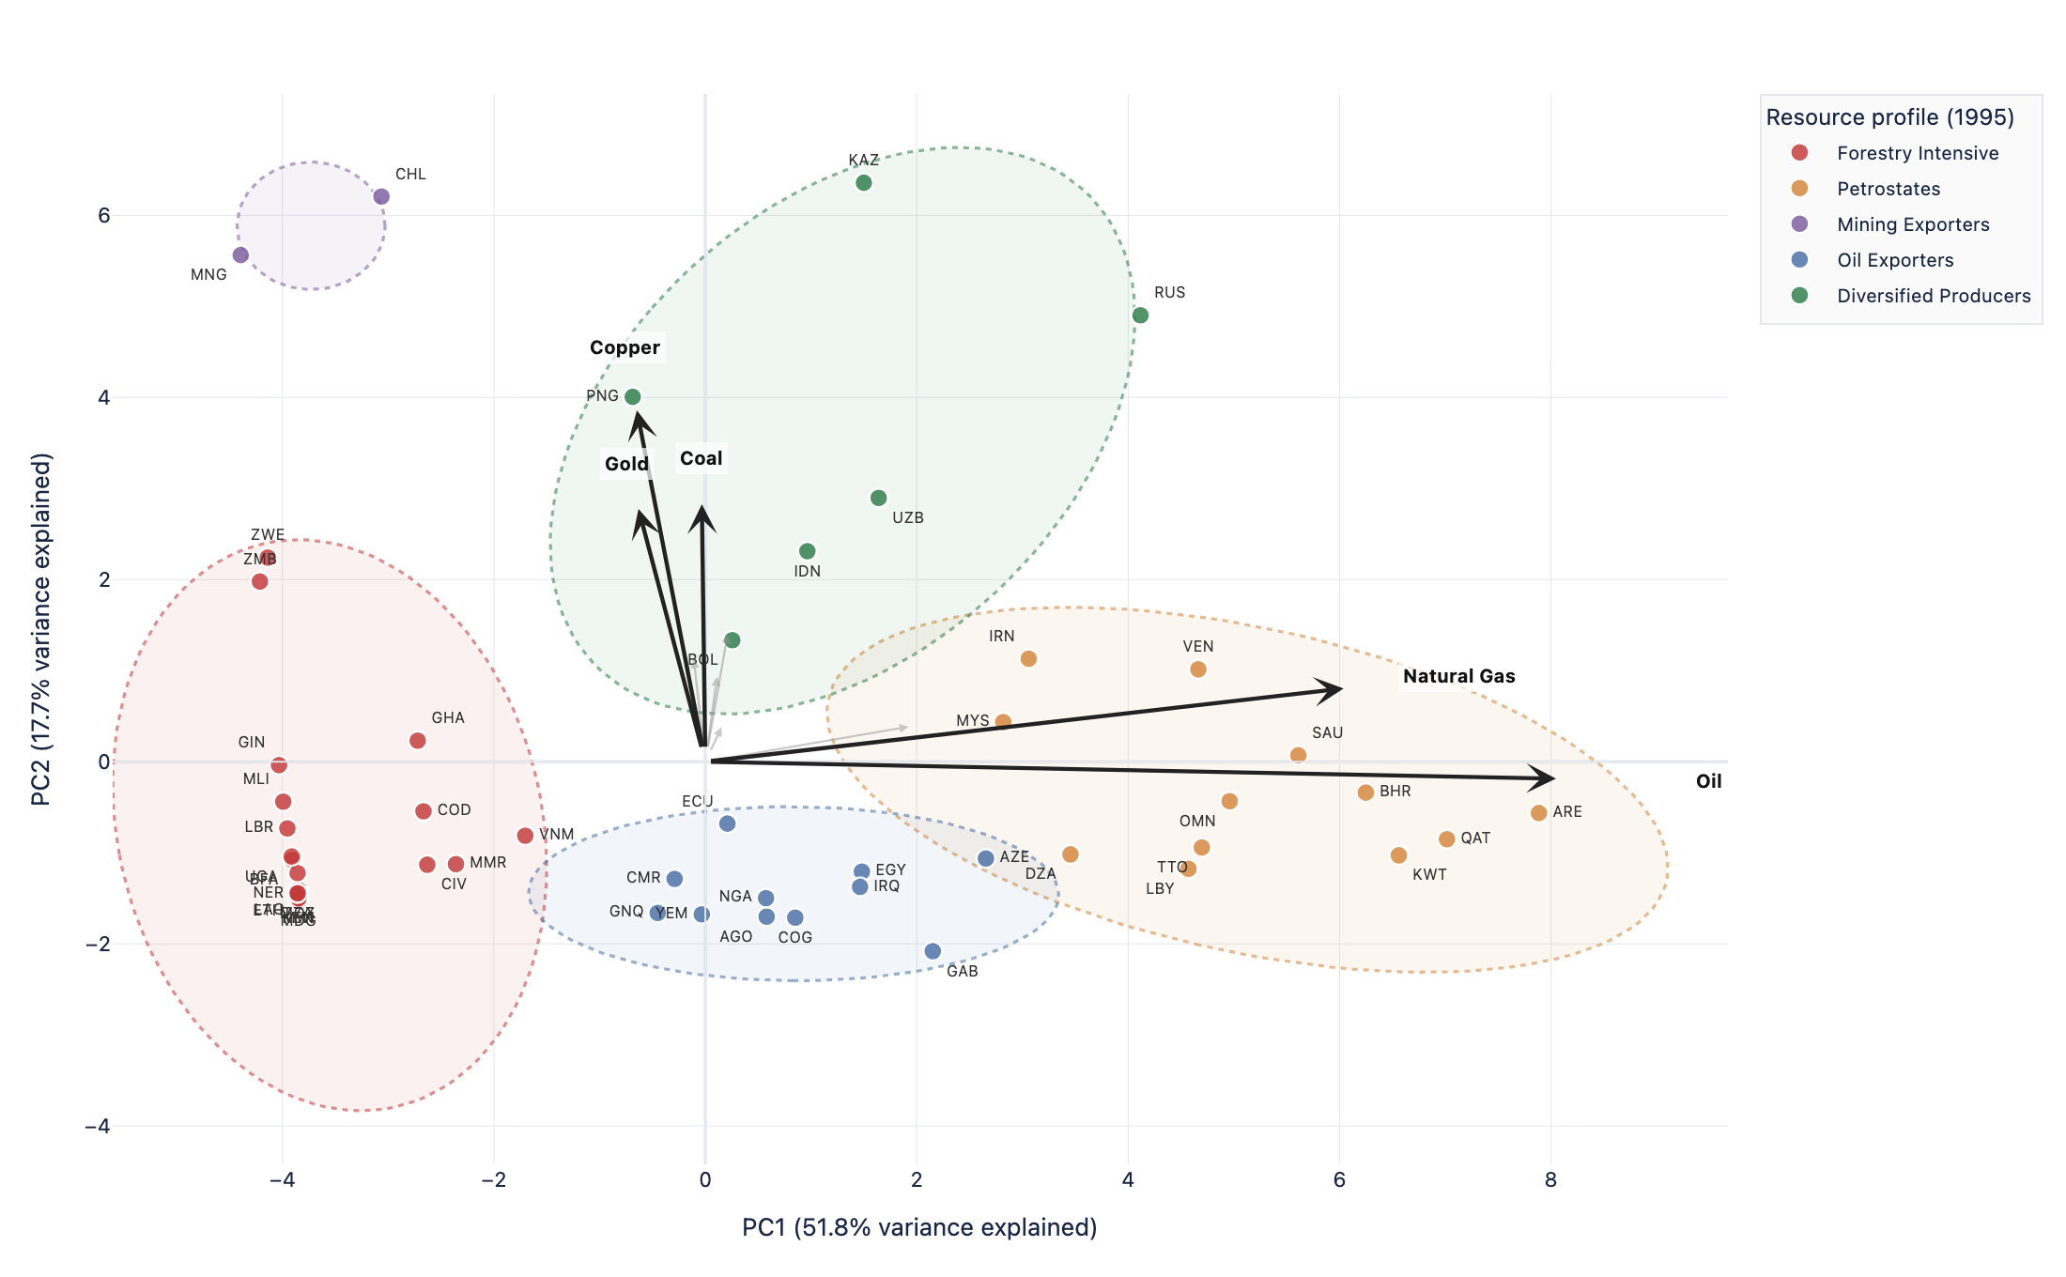
Figure 4. PCA biplot (1995). Countries coloured by k=5 resource-profile cluster. Arrows show PCA loadings for selected resources. Confidence ellipses at 2.5 SD.

2.2 PCA Factor Loadings Heatmap
Figure 5 shows the full loading matrix for PC1 and PC2 across all 21 resource types. PC1 (51.8% of variance) loads almost exclusively on Oil and Natural Gas — the hydrocarbon dimension — with near-zero loadings for all solid minerals. PC2 (17.7%) captures Copper, Gold, Coal, Iron Ore, and Aluminium, constituting the hard-mineral and coal dimension. The remaining resources (Lithium, Cobalt, Graphite, Rare Earths, Vanadium) have negligible loadings on both components, indicating that critical mineral producers are not well-separated in the 1995 PCA space — a reflection of how early-stage these sectors were at the start of the sample period.
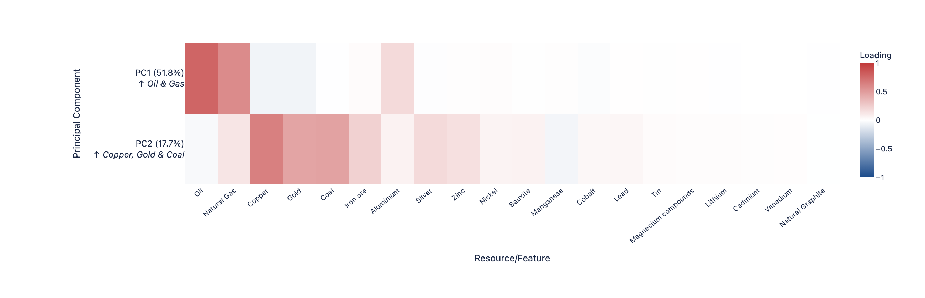
Figure 5. PCA factor loadings heatmap. Rows: PC1 (Oil & Gas) and PC2 (Copper, Gold & Coal). Columns: 21 resource types ordered by PC1 loading.

2.3 Cluster Profiles — Normalised Variable Means (k=5)
Figure 6 compares the five clusters across ten socioeconomic variables, normalised to [0,1] within each variable using the 1995 sample range. Petrostates (orange) and Oil Exporters (blue) have the highest NR and oil rents but diverge sharply on all other dimensions: Petrostates have much higher GDP per capita, human capital, and life expectancy, while Oil Exporters score near the sample minimum on most institutional and development variables. Mining Exporters (purple) score highest on human capital and governance, consistent with the relatively more institutionalised mining sectors in Chile and CIS countries. Forestry Intensive countries (red) are distinguished by agriculture-heavy structures and very low domestic credit. Diversified Producers (green) occupy intermediate positions across most dimensions.
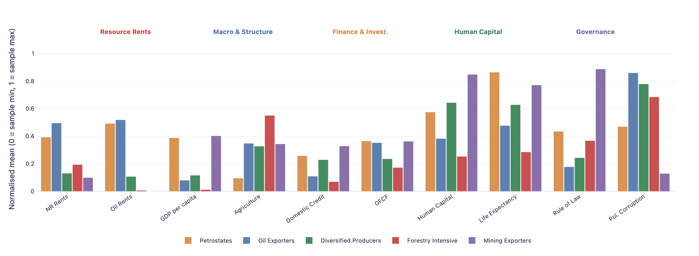
Figure 6. Normalised cluster profiles (k=5, 1995). Each variable is scaled 0–1 across the sample minimum and maximum. Groupings: Resource Rents, Macro & Structure, Finance & Investment, Human Capital, Governance.

2.4 Geographic Distribution — 1995 and 2019
Figures 7a and 7b map the k=4 cluster assignments geographically for 1995 and 2019 respectively. The spatial pattern is strikingly stable over the 24-year period: the Middle East and North Africa remain overwhelmingly Petrostate or Oil Exporter territory, Sub-Saharan Africa remains predominantly Forestry Intensive, and the resource-rich former Soviet states and South America maintain their Major Producer designation. The near-identical appearance of the two maps provides visual confirmation that resource-profile clustering is highly persistent at the country level — a finding that motivates the use of 1995 cluster assignments throughout the regression analysis.
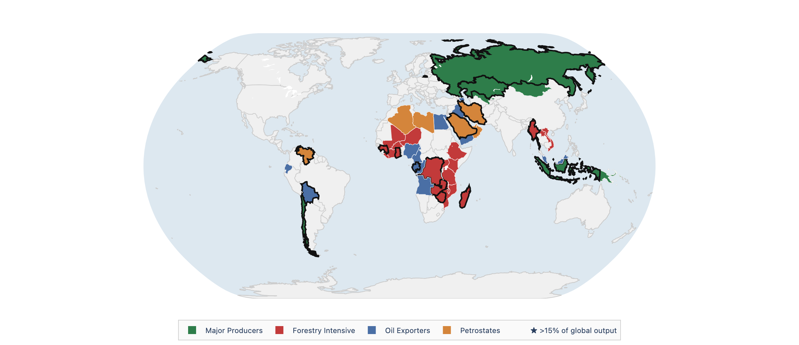
Figure 7a. Geographic distribution of k=4 resource-profile clusters, 1995. Stars denote countries producing >15% of global output in at least one resource.

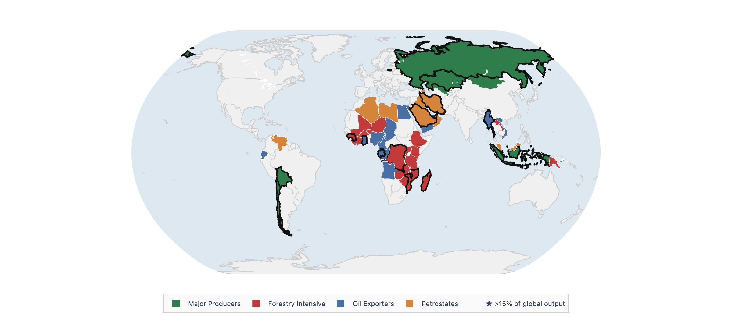
Figure 7b. Geographic distribution of k=4 resource-profile clusters, 2019. Cluster assignments are near-identical to 1995, confirming profile persistence.

3 Regression Results

3.1 Coefficient Comparison — Models 3a and 3b
Figure 8 shows coefficient estimates with 95% confidence intervals (clustered by country) for the parsimonious interaction model without lag (Model 3a, dark) and with lagged ECI (Model 3b, light). The most striking difference is for log(HCI): the estimate shrinks from ~1.63 (3a) to ~0.29 (3b) once ECI_lag1 is controlled for, indicating that much of the apparent human capital effect in the static model is absorbing ECI persistence. The Rule of Law coefficient similarly collapses. The log(HCI) × log(Production) interaction term is positive and marginally significant in Model 3a, consistent with the hypothesis that human capital moderates the resource curse — higher-skill countries partially offset the negative production effect. Production value per capita is consistently negative across both specifications, supporting the resource curse narrative. The interaction and forestry rents terms are not statistically distinguishable from zero in either model.
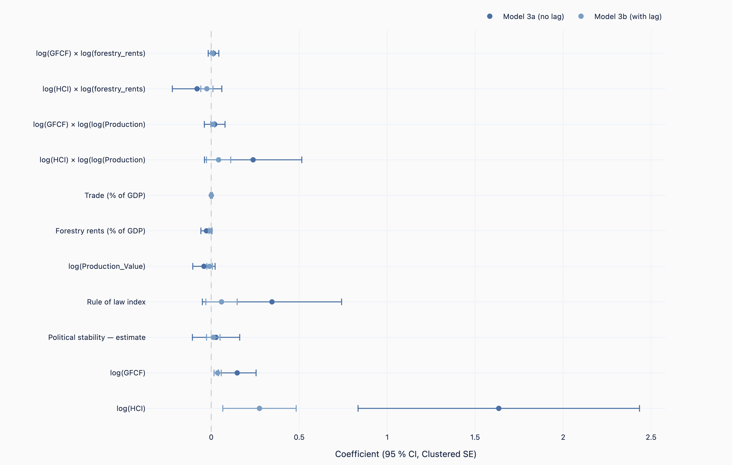
Figure 8. OLS coefficient estimates with 95% CIs (clustered SE by country). Dark: Model 3a (no lag). Light: Model 3b (with ECI_lag1). DV: raw ECI.

4 Machine Learning — Feature Importance and Predictions

4.1 Consensus Feature Importance — LASSO, Ridge, Elastic Net
Figure 9 plots normalised feature importance (min-max scaled to [0,1]) for the three penalised linear models. Domestic Credit is the single most important predictor across all three, consistent with the correlation analysis. HC × Production (the human capital × resource production interaction) ranks second, with notable spread between LASSO/EN (low) and Ridge (higher), reflecting how Ridge retains all features while LASSO shrinks many to zero. Human Capital and Electricity Access complete the top four. The wide confidence intervals on several variables (especially Electricity Access under Ridge) reflect sensitivity to regularisation strength rather than model instability. Lower-ranked variables — Trade, Forestry Rents, Interest Rate — are selected by LASSO but with near-zero weight, suggesting they add marginal predictive value once the top features are included.
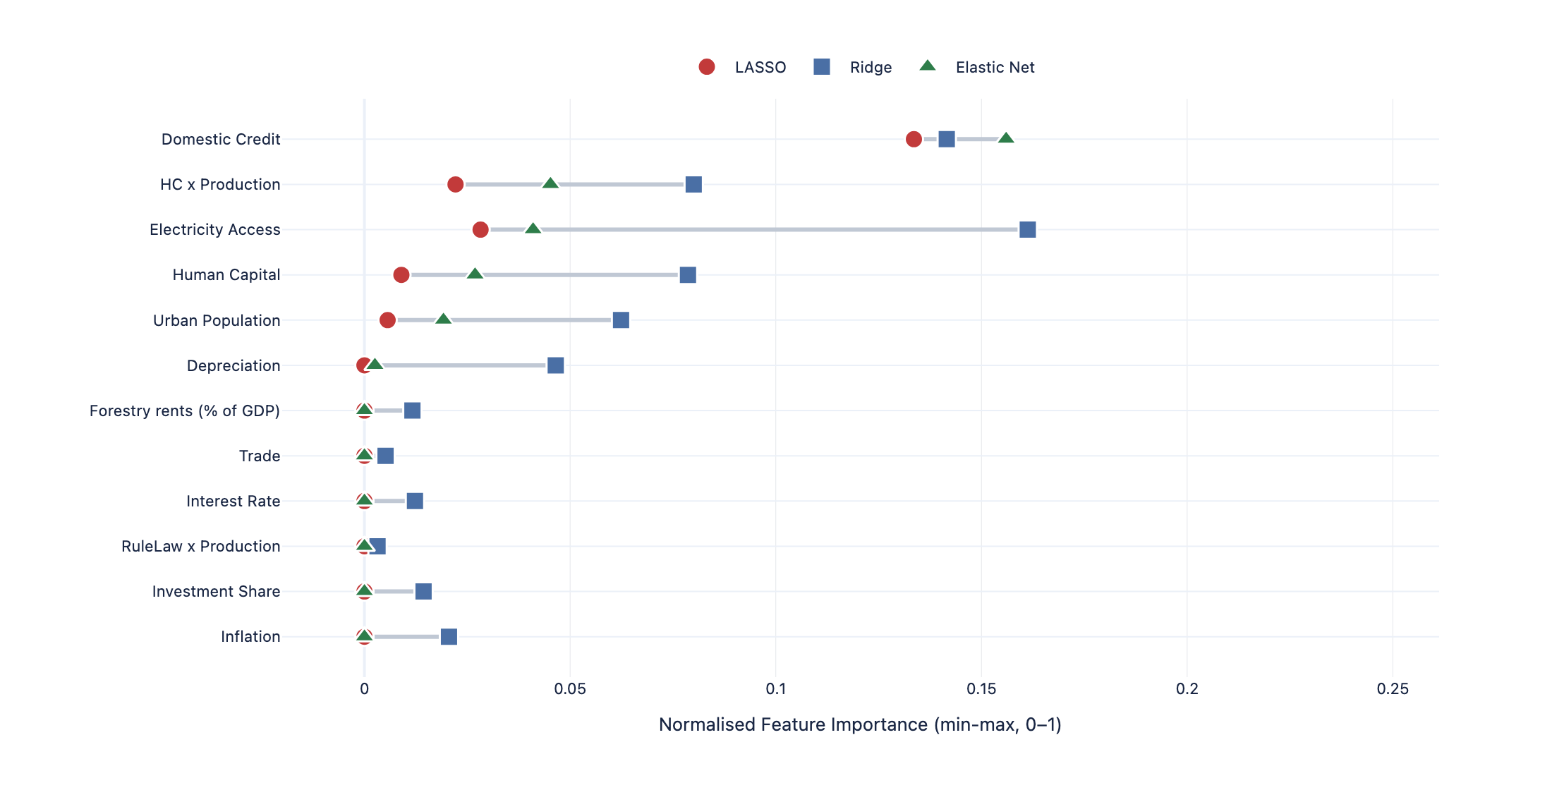
Figure 9. Normalised feature importance for LASSO, Ridge, and Elastic Net (min-max scaled). Lines connect estimates for the same feature across models.

4.2 Random Forest Feature Importance
Figure 10 shows impurity-based feature importance for the Random Forest model, which achieves the highest test R² (0.869). Domestic Credit again ranks first by a wide margin (importance ≈ 0.014), with HC × Production second (0.008). Notably, Rule of Law × Production appears prominently (fourth), reflecting the RF's ability to capture non-linear interactions between institutional quality and resource extraction. Forestry Rents ranks sixth — considerably higher than in the linear models — suggesting a non-linear relationship between renewable resource income and complexity that penalised regression does not fully capture. Production value per capita (Prod Value p.c.) ranks eighth, with a smaller direct effect than implied by the regression coefficients.
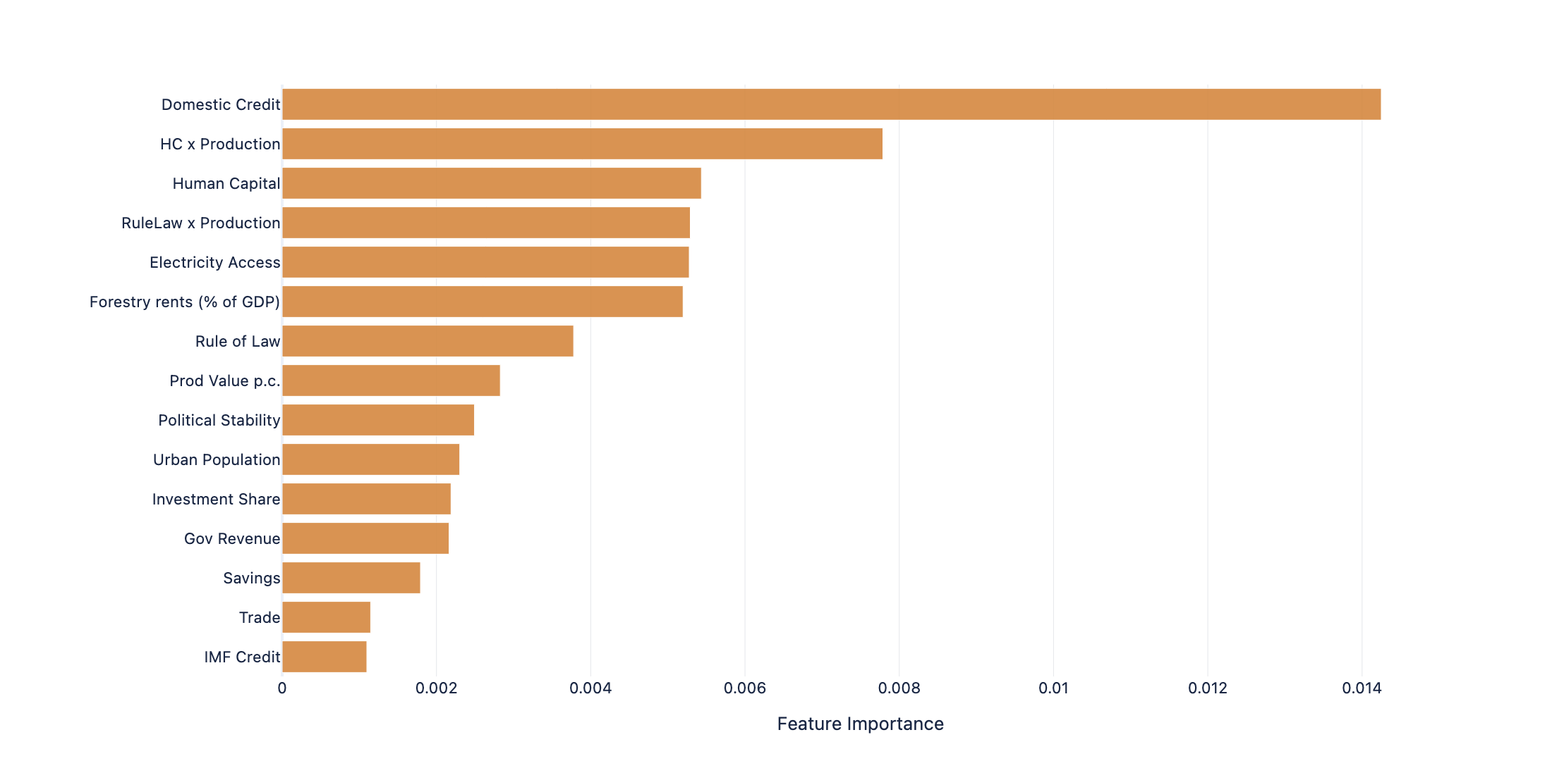
Figure 10. Random Forest feature importance (mean decrease in Gini impurity), top 15 features. ECI_lag1 excluded from display.

4.3 Actual vs Predicted ECI — Test Set (2015–2019)
Figure 11 shows actual against predicted ECI on the 2015–2019 test set for the ECI level (left) and ΔECI (right) targets. The level model produces tight predictions along the 45° line (test R² = 0.869), with the largest residuals for Chad (TCD), Tanzania (TZA), and Congo (COG) — countries where political instability or sharp changes in resource production create structural breaks not captured by the features. The ΔECI model (right) shows much wider scatter around the diagonal, consistent with the inherently noisier nature of predicting year-on-year changes. Iraq (IRQ) is the largest outlier, with a large actual increase in ΔECI (post-2015 reconstruction) that the model cannot anticipate from pre-2015 feature values.
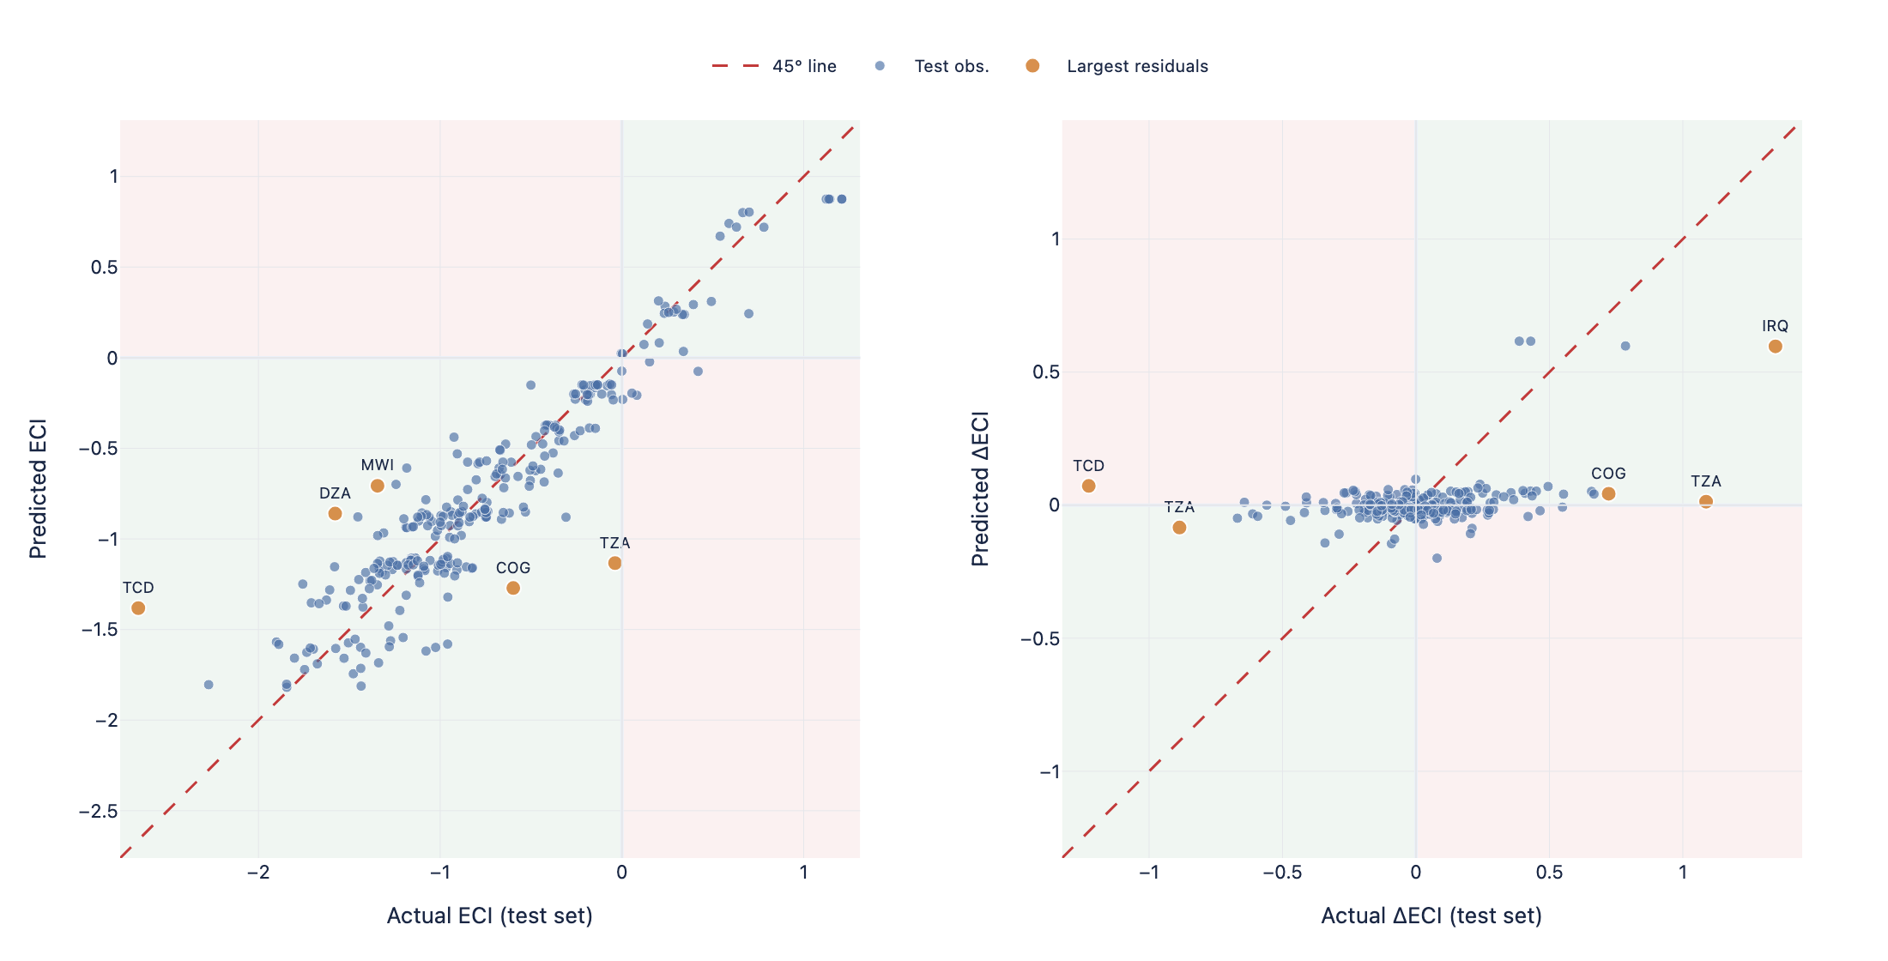
Figure 11. Actual vs predicted ECI (left) and ΔECI (right) on the 2015–2019 test set. Orange points: largest-residual countries. Red dashed line: 45° perfect-fit.

4.4 ECI Forecast 2020–2030
Figure 12 presents country-level ECI forecasts from 2020 to 2030, produced by the Random Forest model retrained on the full 1995–2019 sample. The left panel highlights the top three improvers — Equatorial Guinea (GNQ), Mongolia (MNG), and Ecuador (ECU) — all showing projected ECI gains of 0.3–0.5 units over the decade, driven primarily by improving human capital and domestic credit trajectories extrapolated from 2015–2019 trends. The right panel shows the bottom three decliners: Saudi Arabia (SAU), Zimbabwe (ZWE), and Libya (LBY). SAU's projected decline reflects continued hydrocarbon dependence under the model's feature projections, while ZWE and LBY face structural headwinds from political instability. The shaded bands represent bootstrap prediction intervals (1,000 resamples). Note that these forecasts are model-extrapolations conditional on feature trends and should be interpreted with caution beyond 2025.
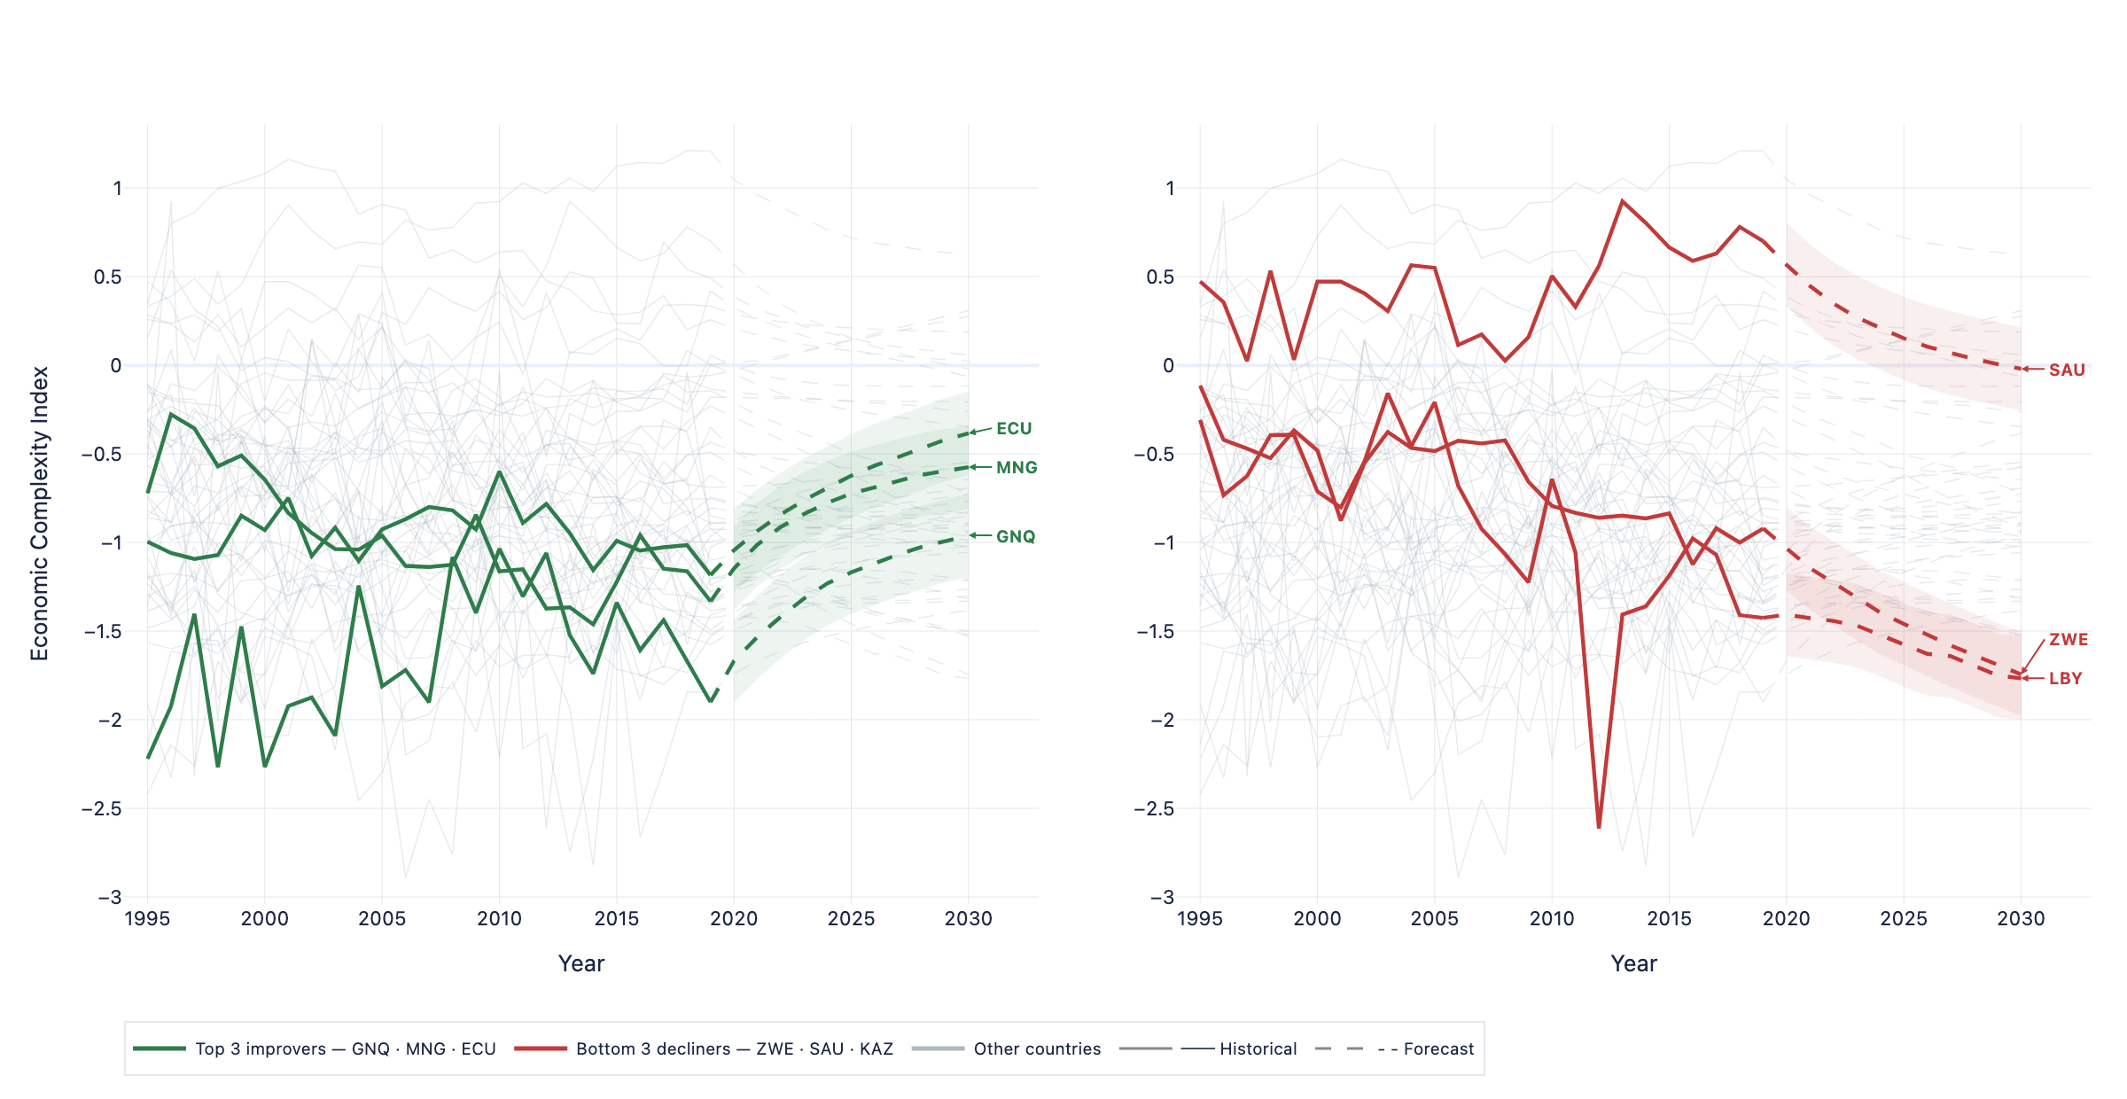
Figure 12. ECI forecasts 2020–2030 (Random Forest). Left: top 3 projected improvers (GNQ, MNG, ECU). Right: bottom 3 projected decliners (SAU, ZWE, LBY). Shaded bands: bootstrap prediction intervals. Grey lines: all other countries.

4.5 ECI Forecast Heatmap — All Countries
Figure 13 provides a full-panel view of historical ECI (1995–2019) and forecasted ECI (2020–2030) for all 54 countries, sorted by 2019 ECI level (highest at top). Russia (RUS) and Saudi Arabia (KWT, SAU) anchor the top rows with consistently high (blue) ECI values. The transition at the dotted 2020 line reveals the forecast regime: the post-2020 cells show a gradual convergence to intermediate values for most countries, reflecting the model's tendency to regress toward the mean in the absence of structural breaks. Iraq (IRQ) and Equatorial Guinea (GNQ), at the bottom, show the most dynamic historical patterns, with deep red cells reflecting conflict-period ECI collapses followed by partial recoveries.
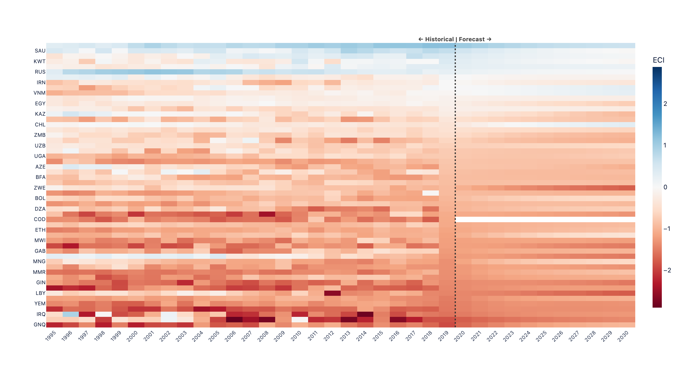
Figure 13. ECI heatmap for all 54 countries, 1995–2030 (historical left of dotted line, forecast right). Blue = high ECI, red = low ECI. Countries sorted by 2019 ECI.

5 Robustness Checks — LOCO Analysis

5.1 LOCO Coefficient Stability — Penalised ML Models
Figure 14 presents Leave-One-Country-Out (LOCO) coefficient stability for ElasticNet (left) and LASSO (right). Each dot is the mean coefficient across all 54 leave-one-out iterations; the line spans the min–max range; the tick mark indicates the full-sample estimate. Domestic Credit is the most stable predictor in both models — the range of LOCO estimates is narrow relative to the mean, and the full-sample estimate sits close to the LOCO mean. HC × Production and Electricity Access show wider ranges, indicating that a small number of influential countries drive part of their estimated effects. Depreciation (red dot) has a negative sign that is sensitive to sample composition. Variables with very narrow ranges (Prod Value p.c., Rule of Law, Political Stability, Trade) are robust to any single country exclusion, providing confidence in their direction and approximate magnitude across the LOCO experiments.
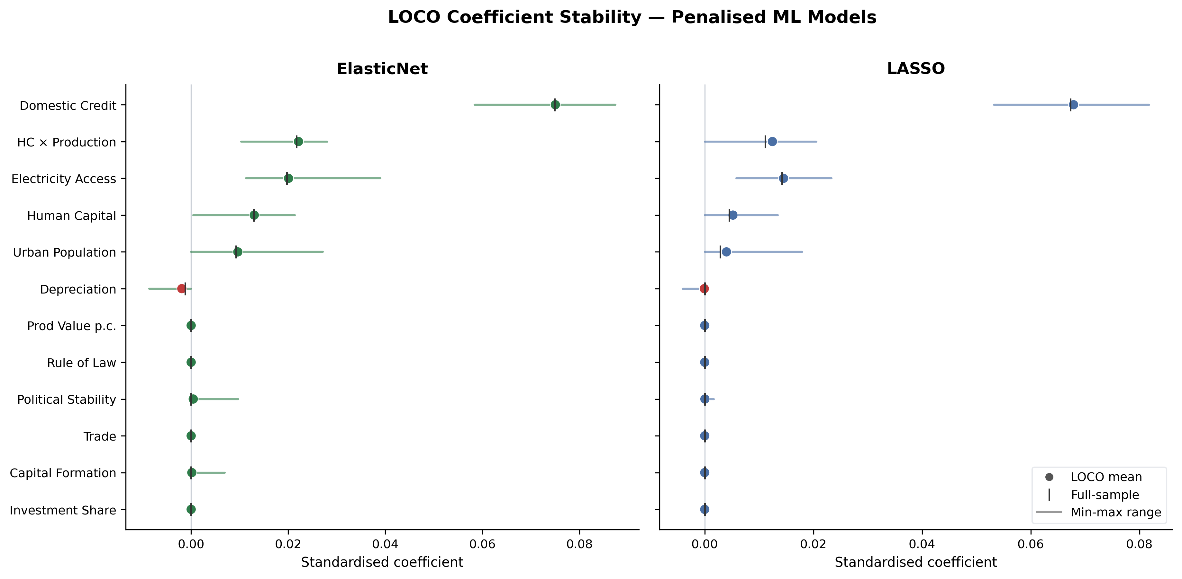
Figure 14. LOCO coefficient stability for ElasticNet (left) and LASSO (right). Dot: LOCO mean. Tick: full-sample estimate. Line: min–max range across 54 iterations.

5.2 LOCO Test R² Stability — All ML Models
Figure 15 shows how test R² changes when each country is excluded from training, for all four ML models. Dashed horizontal lines mark full-sample test R² benchmarks. Random Forest (red) is consistently the top performer at every exclusion, but shows some sensitivity to the exclusion of BHR (Bahrain) — a small country whose removal slightly improves RF performance, suggesting it is a mildly influential outlier. LASSO, Ridge, and Elastic Net are nearly indistinguishable from each other and remain tightly clustered around the full-sample benchmark across all exclusions, confirming that no single country is so influential as to meaningfully alter the linear model estimates. Tanzania (TZA) exclusion modestly improves all models, consistent with it being a high-residual observation in the test set.
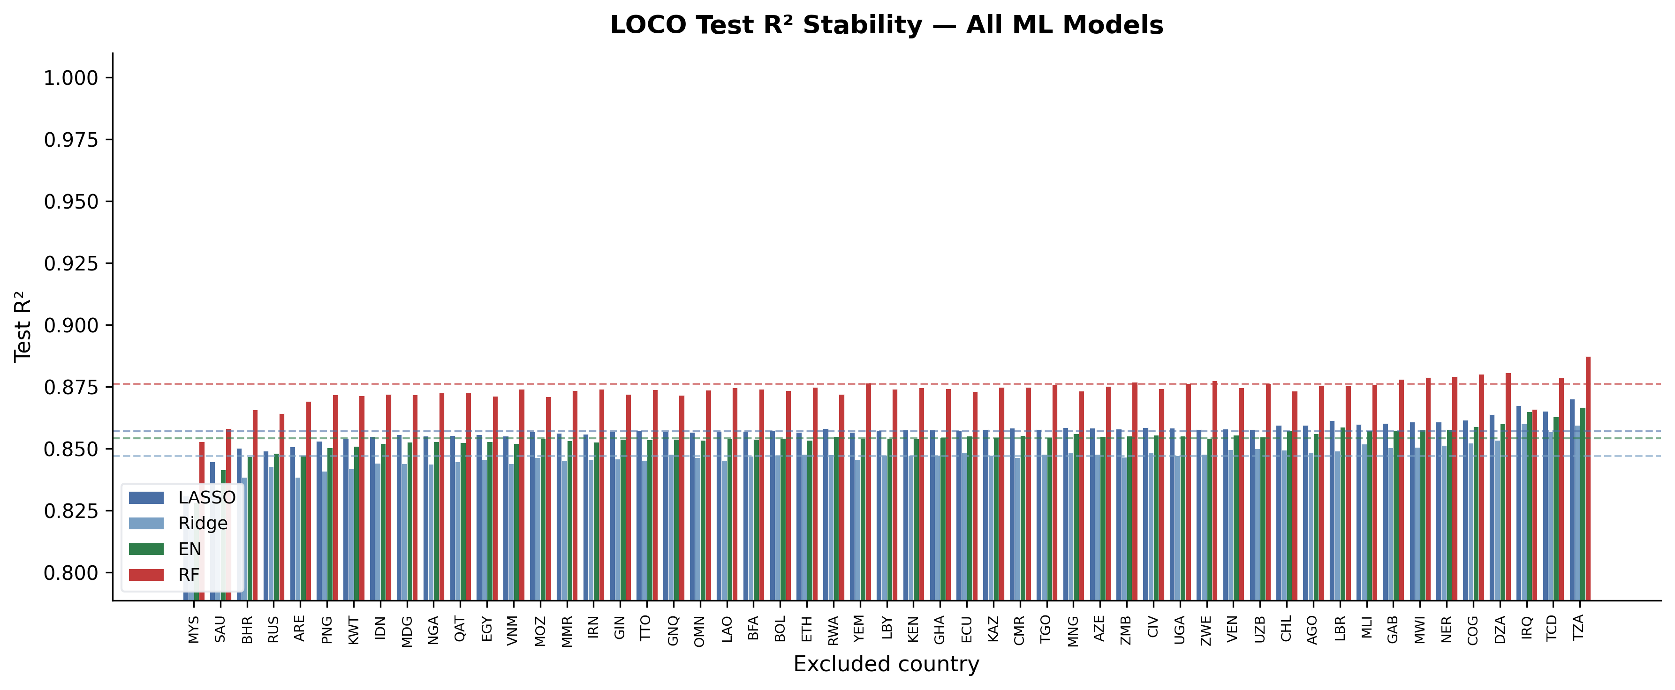
Figure 15. LOCO test R² for each of the 54 country exclusions, all ML models. Dashed lines: full-sample test R² benchmarks. Countries sorted by median LOCO R².

Appendix A — ML Model Robustness: Leave-One-Country-Out
The Leave-One-Country-Out (LOCO) procedure removes each of the 54 sample countries in turn, refits LASSO, Ridge, ElasticNet, and Random Forest on the remaining 53, and records test-set R² and standardised coefficients. Full-sample baselines: LASSO 0.857, Ridge 0.847, ElasticNet 0.854, RF 0.876.

A.1 Coefficient Stability — ElasticNet and LASSO
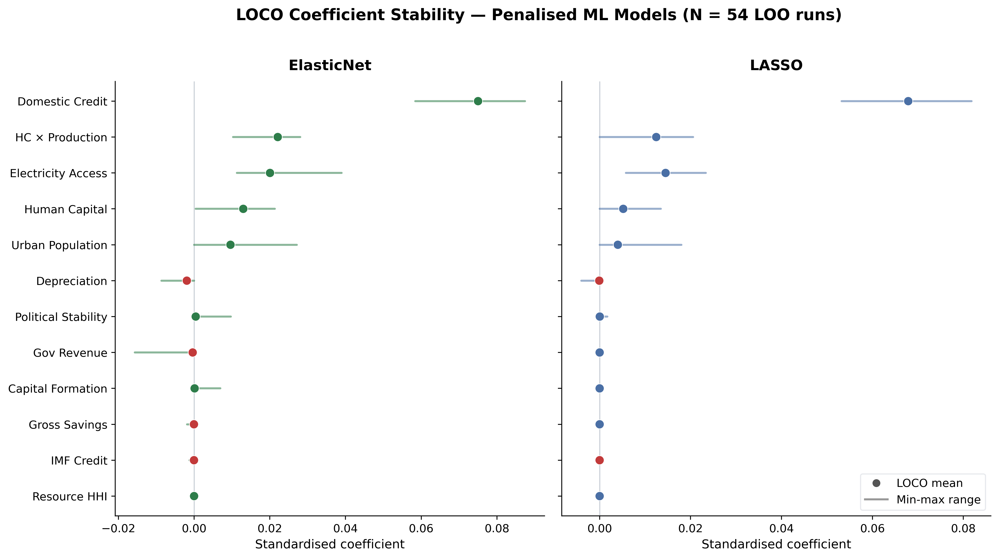
Figure A1 — LOCO coefficient stability: ElasticNet (left) and LASSO (right). Dots show the cross-LOO mean standardised coefficient for the top 12 features by absolute magnitude (Lagged ECI excluded for scale). Horizontal bars span the full min-max range across all 54 runs. Both models agree on sign for every top-ranked feature across all LOO runs. Human Capital, Rule of Law, and Political Stability are consistently positive; IMF Credit and Inflation are consistently negative. The narrowness of the ranges confirms no single country drives directionality.

A.2 Test R² Stability — All Four Models
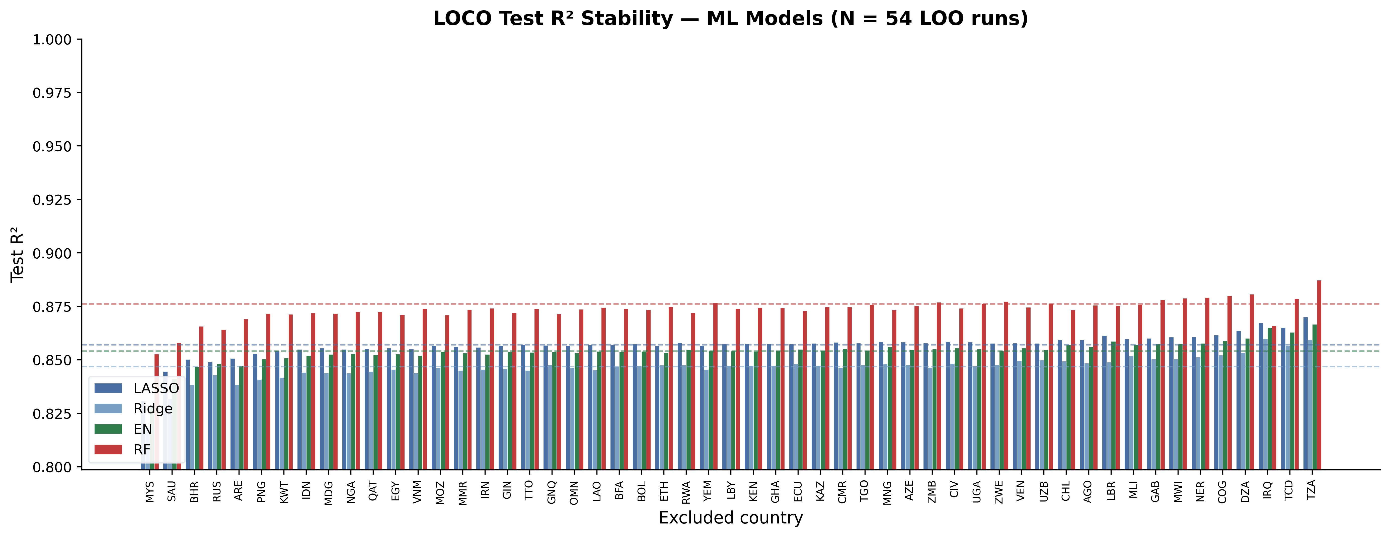
Figure A2 — LOCO test R² per excluded country: LASSO, Ridge, ElasticNet, RF. Grouped bars show test R² for each of the 54 LOO runs; dashed lines mark full-sample baselines. R² standard deviations across runs: LASSO 0.005, Ridge 0.006, EN 0.005, RF 0.005. The maximum drop from baseline never exceeds 0.04 absolute points for any model. Random Forest is the most stable and consistently highest-performing. Countries are sorted left-to-right by ascending mean R² across the four models.

Appendix B — OLS Regression Robustness: Leave-One-Country-Out
The same LOCO procedure is applied to OLS Models 3a (without lagged ECI) and 3b (with lagged ECI). For each LOO run a plain OLS is fitted on the 53-country sub-sample — matching the specification of NB6 — and the resulting coefficients and R² are recorded. Full-sample baselines (Driscoll–Kraay SEs): Model 3a R² = 0.359; Model 3b R² = 0.785.

B.1 Coefficient Stability — Models 3a and 3b
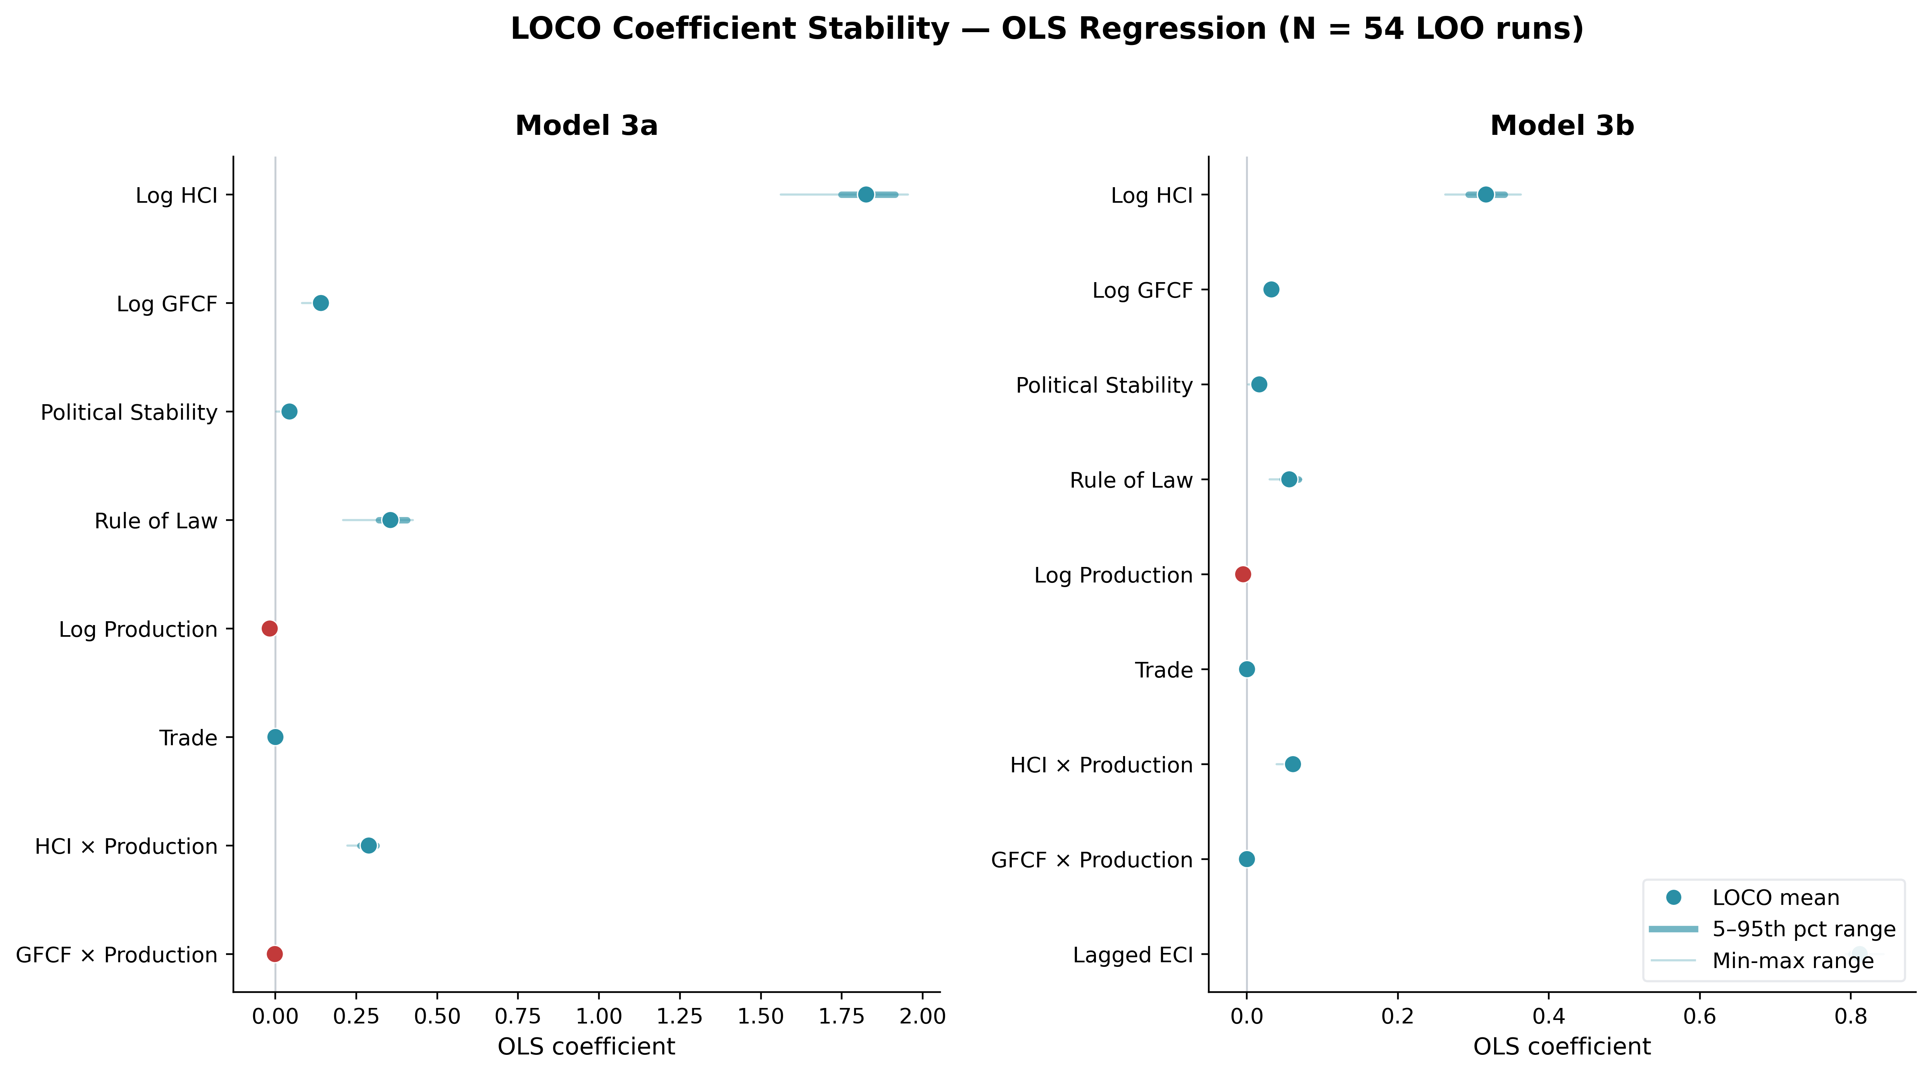
Figure B1 — LOCO coefficient stability: OLS Models 3a (left) and 3b (right). Thick bars span the 5th–95th percentile of coefficients across 54 LOO runs; thin bars show the full min-max range. Dots show the cross-LOO mean. Log HCI, Rule of Law, Political Stability, and HCI×Production are 100% sign-consistent in both models. Log Production Value is 96–100% sign-stable. GFCF×Production is the only variable with weak sign instability (~57–74%), consistent with its near-zero point estimate in the full-sample specification. Lagged ECI (Model 3b) is perfectly sign-stable with an extremely tight range (SD = 0.007).

B.2 R² Stability — Models 3a and 3b
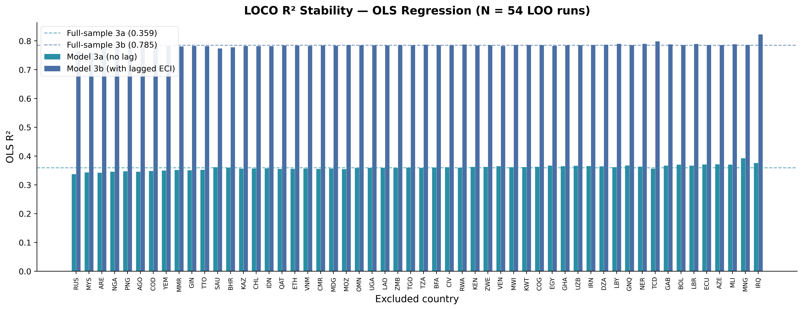
Figure B2 — LOCO R² per excluded country: Models 3a and 3b. Model 3a R² ranges from 0.338 to 0.393 across LOO runs (mean 0.360, SD 0.009); Model 3b R² ranges from 0.761 to 0.823 (mean 0.785, SD 0.008). Dashed lines mark the full-sample baselines. The ~0.43 gap between 3a and 3b is present for every single excluded country, confirming that the explanatory power of lagged ECI is not attributable to any particular country's leverage.

